
SHIRE HIGHLANDS EDUCATION DIVISION
2026 MALAWI SCHOOL CERTIFICATE OF EDUCATION MOCK
EXAMINATION

HOME ECONOMICS
Monday, 9 March 2026 Subject Number: M082/I
Time Allowed: 2 hours 30 minutes
1:30pm-4:00pm
PAPER I
(100 marks)
Theory
Instructions
Question  Number | Tick if  answered | Do not write in  These column
1
2
3
4
5
6
7
8
9
10
11
12
13
14
TOTAL
- This paper contains 10 printed pages. Please check.

- Write your name at the top of all pages of the question paper.
- This paper has two sections A and B. section A has eleven questions and section B has three questions.

- Answer all questions in section A and two questions only from section B in the spaces provided on the question paper.

- The maximum number of marks for each answer is indicated against each question.

- In the table provided on this page, tick against the question number you have answered.

SECTION A (70 MARKS)
Answer all the eleven questions in this section in the space provided.
- a. State any two roles that herbal therapy play in the management of HIV/AIDS.
- _______________________________________________________________________
- _______________________________________________________________________
(2 marks)
b. Explain how food industry can help in the management of HIV/AIDS.
___________________________________________________________________________
___________________________________________________________________________
(2 marks)
c. Describe the following feeding options for babies born to an HIV and AIDS infected mothers.
- wet-nursing __________________________________________________________________________________________________________________________________________
(2 marks)
- expressive breast feeding __________________________________________________________________________________________________________________________________________
(2 marks)
- a. Figure 1 shows two scenarios of how wheat flour can be measured. Use it to answer the
questions that follow.

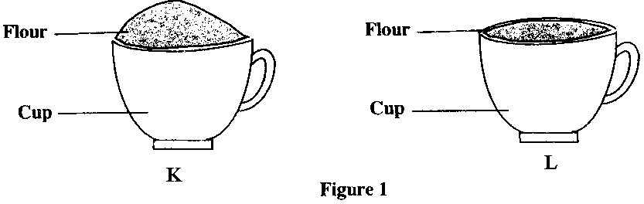

- Which one is the correct way of measuring ingredients? ______________________________________________________________________________
(1 mark)
- Give a reason for your answer in 2 a i. ______________________________________________________________________________
(2 marks)
b. Apart from a cup, mention any other two equipment for measuring dry ingredients.
i. _____________________________________________________________________
ii. _____________________________________________________________________

(2 marks)
c. Explain a role that nutrition plays to each of the following good grooming practices.
- Caring for the teeth ______________________________________________________________________________________________________________________________________________________
(2 marks)
- Caring for the skin ______________________________________________________________________________________________________________________________________________________
(2 marks)
- a. Mention any two food related diseases that may occur due to eating too much fats.
- ____________________________________________________________________
- ____________________________________________________________________
(2 marks)
b. Why is it more advisable to eat more fatty foods in cold season?
______________________________________________________________________________________________________________________________________________________
(2 marks)
c. Define the following terms:
- Deamination ______________________________________________________________________________________________________________________________________________________
(1 mark)
- Invisible fat ______________________________________________________________________________________________________________________________________________________
(1 mark)
d. How do the following factors affect meal planning?
- age ______________________________________________________________________________________________________________________________________________________
(2 marks)
- occasion ______________________________________________________________________________________________________________________________________________________
(2 marks)
- a. Explain any two ways of generating savings.
- ________________________________________________________________________________________________________________________________________________
- ________________________________________________________________________________________________________________________________________________
(4 marks)
b. State any two disadvantages of life insurance.
___________________________________________________________________________________________________________________________________________________________________________________________________________________________________________________________________________________________________(2 marks)
- a. Differentiate “buffet” from “cocktail” in entertainment.
_________________________________________________________________________________________________________________________________________________________________________________________________________________________________
(2 marks)
b. State any two uses of a table cloth.
- __________________________________________________________________________________________________________________________________________
- __________________________________________________________________________________________________________________________________________
(2 marks)
c. Describe diversification as a risk management strategy in business.
__________________________________________________________________________
___________________________________________________________________________
___________________________________________________________________________
(2 marks)
- a. How do the following factors influence changes in fashion:
- Politics ______________________________________________________________________________________________________________________________________________________
(2 marks)
- Income ______________________________________________________________________________________________________________________________________________________
(2 marks)
b. Mention any two ways of managing a freezer.
i. _____________________________________________________________________
ii. _____________________________________________________________________
(2 marks)
- a. List any two organisations a consumer can complain to if products are not sold with adequate
information.
- _____________________________________________________________________
- _____________________________________________________________________
(2 marks)
b. Give any two roles of housing institutions in Malawi.
___________________________________________________________________________
__________________________________________________________________________
(2 marks)
- Figure 2 is a diagram showing the structure of meat. Use it to answer the questions that follow.
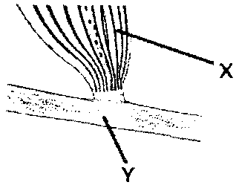
- Mention the parts labelled X and Y.
X ___________________________________________________________________________
Y ___________________________________________________________________________
(2 marks)
- Explain any two ways of making part X tender.
- ______________________________________________________________________________________________________________________________________________________
- ______________________________________________________________________________________________________________________________________________________
(2 marks)
- What type of protein is found in the connective tissue? ___________________________________________________________________________
(1 mark)
- a. Why should frozen food be thoroughly thawed before cooking?
______________________________________________________________________________________________________________________________________________________
(2 marks)
- Mention any two uses of shortening in flour mixtures.
- ___________________________________________________________________________
- ___________________________________________________________________________
(2 marks)
10. Mr Chidothi who has never gone to school starts operating a small scale business.
a. Which two challenges is Mr Chidothi likely to face as he runs his business.
- ____________________________________________________________________________________________________________________________________________
- ____________________________________________________________________________________________________________________________________________
(2 marks)
b. State any two sources from where Mr Chidothi would obtain capital for starting his business.
- ______________________________________________________________________
- ______________________________________________________________________
(2 marks)
c. Realising that Mr Chidothi’s business is not prospering, discuss two measures he would use to improve on his business.
- ____________________________________________________________________________________________________________________________________________
- ____________________________________________________________________________________________________________________________________________
(4 marks)
- a. Why should shoes be stuffed with paper when not in use?
______________________________________________________________________________________________________________________________________________________
(2 marks)
b. State any two ways you can prevent food related disorders.
- _____________________________________________________________________
- _____________________________________________________________________
(2 marks)

Section B (30 MARKS)
Answer any two questions from this section.
- a. A person portrays the following patterns of behaviour, noisy, irritable, loss of
memory, emotional difficulties in hearing. Use this information to answer the questions that follow.
- What stage of human growth and development is the person? __________________________________________________________________________________________________________________________________________________
(1 mark)
- Describe any three challenges this person may face.
- ______________________________________________________________________________________________________________________________________
- ______________________________________________________________________________________________________________________________________
- ______________________________________________________________________________________________________________________________________
(6 marks)
b. Plan a 3-course lunch to meet the nutritional needs of an elderly person.

(6 marks)
- Mention any two guidelines for caring a pit latrine.
- ___________________________________________________________________________
- ___________________________________________________________________________
(2 marks)
- a. Describe the following mechanical methods of introducing air into flour
Mixtures.
i. sifting
___________________________________________________________________________
___________________________________________________________________________
ii. kneading
______________________________________________________________________________________________________________________________________________________
iii. creaming
______________________________________________________________________________________________________________________________________________________
iv. whisking
______________________________________________________________________________________________________________________________________________________
v. folding and rolling
______________________________________________________________________________________________________________________________________________________
(10 marks)
b. Give three reasons for processing food
_________________________________________________________________________________________________________________________________________________________________________________________________________________________________
(3 marks)
c. Mention any two information found on a product label.
i. _________________________________________________________
ii. _________________________________________________________
(2 marks)
- a. Describe any five responsibilities of a consumer.
________________________________________________________________________________________________________________________________________________________________________________________________________________________________________________________________________________________________________________________________________________________________________________________________________________________________________________________________________________________________________________________________________________________________________________________________________________________________________________________________________________________________________________________________________________________________________________________________________________________________________________________________________________________________________________________________________________________________________________________________________________________________________________________________________________________________________________________________________________________________________________________________________________________________________________
(10 marks)
b. Explain two ways in which a will can help to avoid property grabbing.
- __________________________________________________________________________________________________________________________________________
- __________________________________________________________________________________________________________________________________________
(4 marks)
c. Define a share.
___________________________________________________________________________
___________________________________________________________________________
(1 mark)
END OF QUESTIONS PAPER

